|  |
| --- |
|  |
|  |

|  |
| --- |
| **"Pizza sales analysis Using SQL"** |



Objective :-

"This project demonstrates my skills in SQL by analyzing, querying, and managing a sample database to extract meaningful insights."

Overview :-

"In this project, I showcase my SQL proficiency through complex queries, data manipulation techniques, and database management. The dataset used represents sales data, and I applied various SQL functions such as joins, subqueries, aggregation, and data transformation."

Question No.1

Retrieve the total number of orders placed.

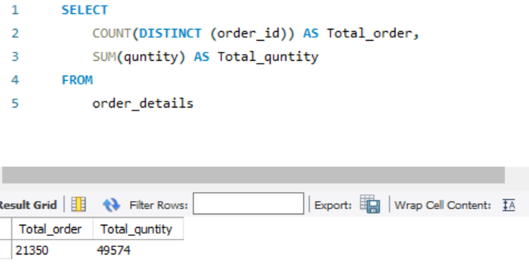

Question No.2

Calculate the total revenue generated from pizza sales.

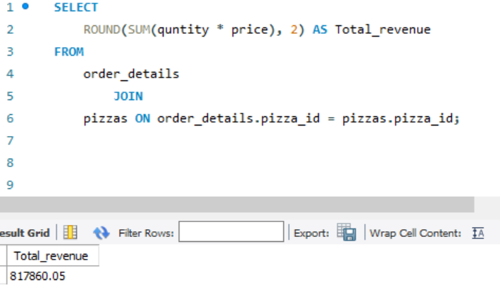

Question No.3

Identify the highest-priced pizza.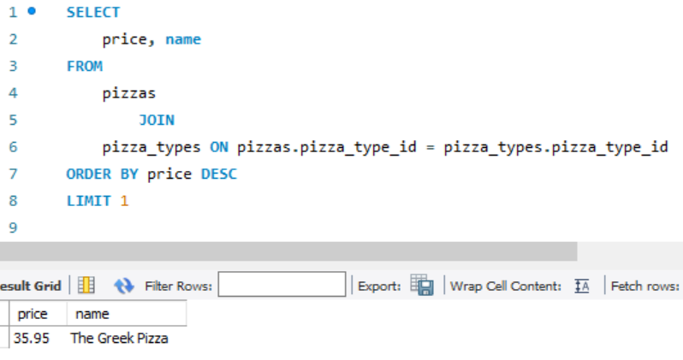

Question No.4

Identify the most common pizza size ordered.

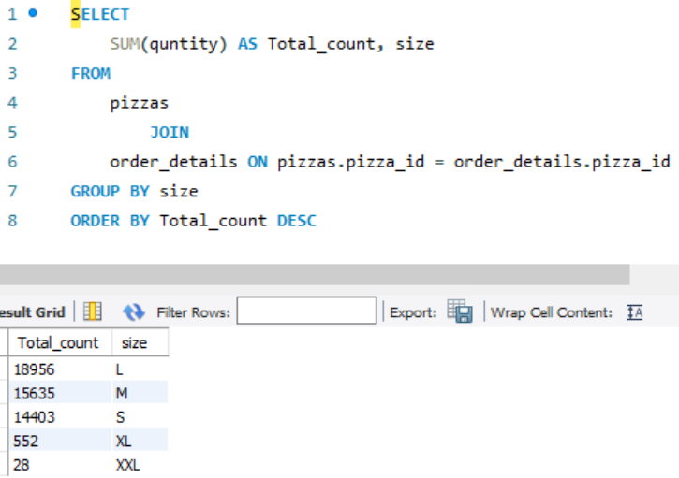

Question No.5

List the top 5 most ordered pizza types along with their quantities.

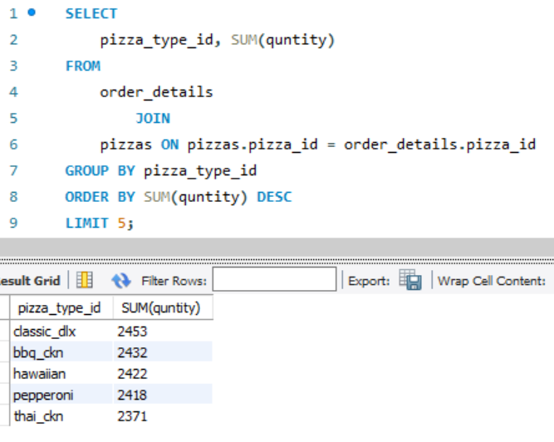

Question No.6

Join the necessary tables to find the total quantity of each pizza category ordered.

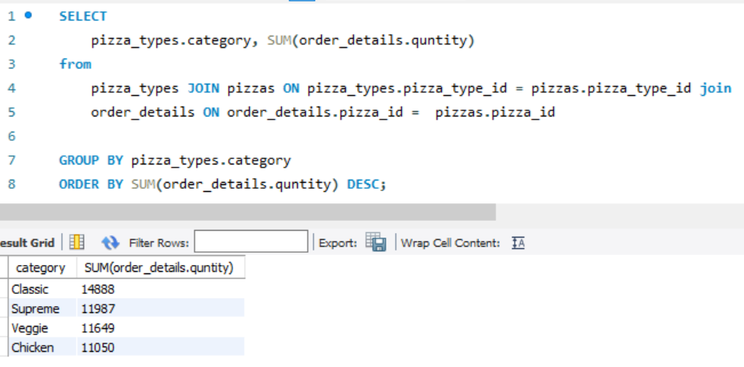

Question No.7

Determine the distribution of orders by hour of the day.

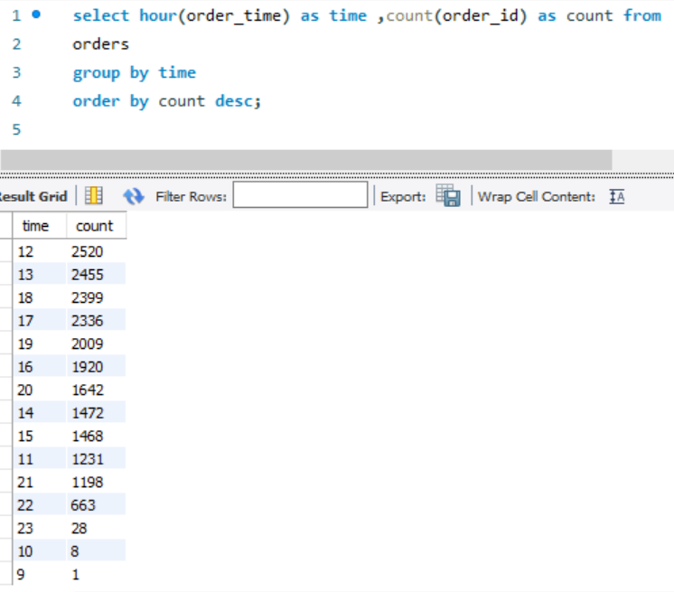

Question No.8

Group the orders by date and calculate the average number of pizzas ordered per day.

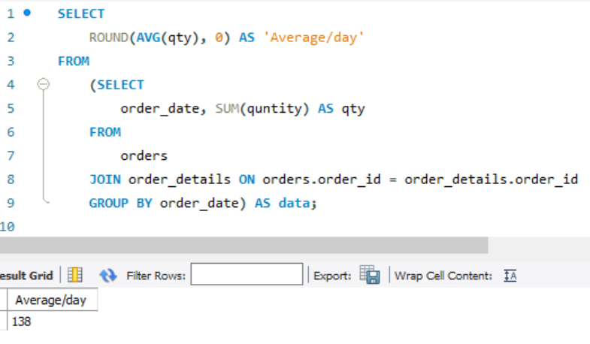

Question No.9

Determine the top 3 most ordered pizza types based on revenue.

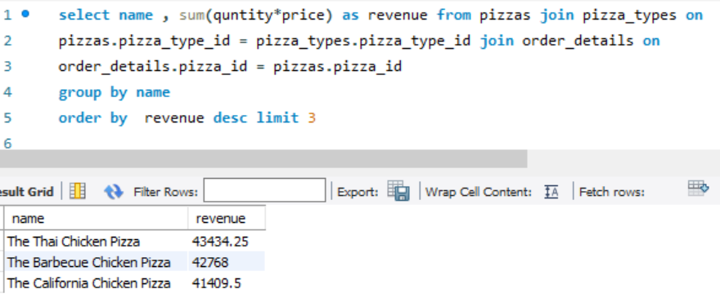

Question No.10

Calculate the percentage contribution of each pizza type to total revenue.

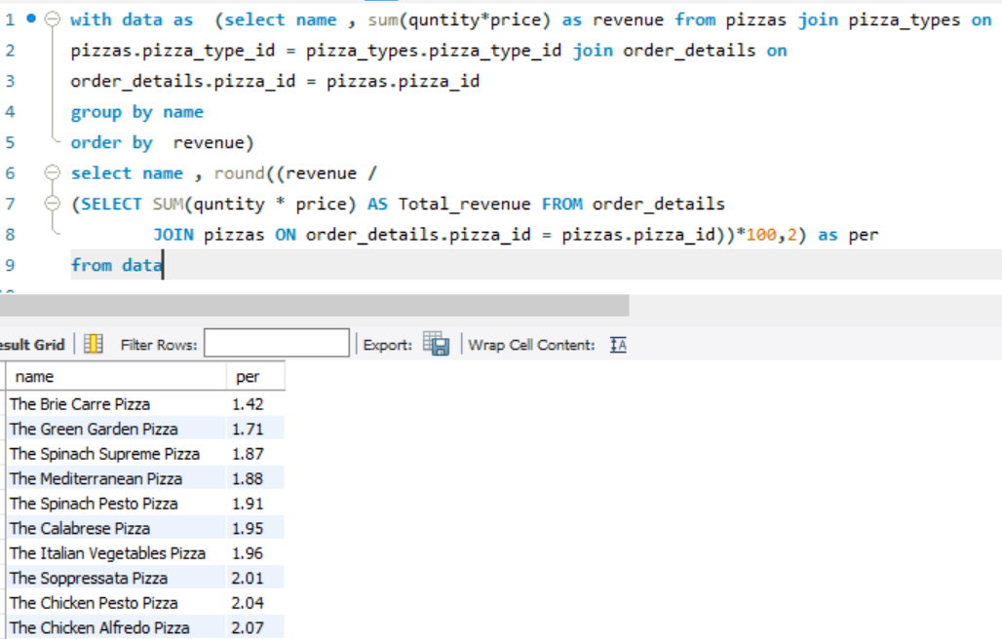

Question No.11

Analyze the cumulative revenue generated over time.

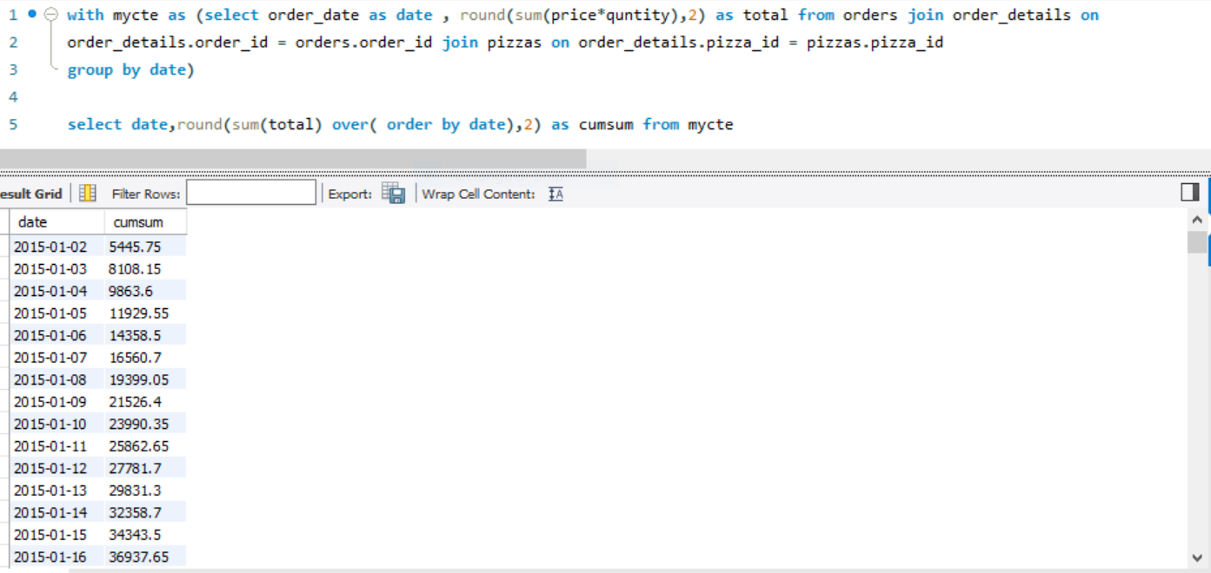

Question No.12 Determine the top 3 most ordered pizza types based on revenue for each pizza category.

